Be a Woodland Park Middle School Bulldog Booster!
The PTO is asking for your contribution of any dollar amount to help us provide financial support for school goals and student programs.
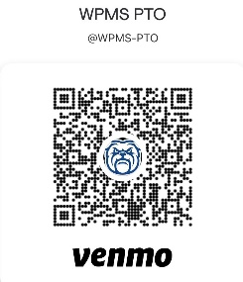
All donations of $50 or more will get an exclusive donor gift!
How can you help? Your student will bring home a Bulldog Booster envelope that they can return to the WPMS Front Office with your cash or check (made out to WPMS PTO) donation. Or you can donate directly through Venmo (@wpms-pto). Don’t forget to include your family name so we can add you to our Bulldog Booster recognition wall!
Questions: Woodlandparkpto@gmail.com
Like us on Instagram - https://www.instagram.com/wpmspto/
and Facebook - https://www.facebook.com/WPMSBulldogs

